**IS187x - BLEDK3 v1.00 Manual Pattern Tool**

**User Guide**

Table of Contents

1. Overview 4

2. Hardware Environment 5

2.1 Top View of BLEDK3 EVB 5

2.2 Environment Setup 5

3. Tool Overview 6

4. BLEDK3 Commands 7

4.1 Common Page 7

4.2 GAP Page 8

4.3 Passkey Page 9

4.4 Transparent Page 10

4.5 ADV / SR Data Page 12

4.6 SMP Page 14

4.7 DIO Page 15

4.8 GATT Client Page 16

4.9 GATT Server Page 17

4.10 Remote GATT Table Page 18

4.11 Local GATT Table Page 20

5. Examples of Operation 22

5.1 Connection 22

5.1.1 Slave Role 22

5.1.2 Connection Complete 23

5.2 Disconnection 24

5.3 Transparent Service 26

5.3.1 Transparent Operation 26

5.4 ADV / SR Data Editor 29

5.4.1 Edit the advertising data and the scan response data 29

5.4.2 Save as a file 30

5.4.3 Update ADV data 30

5.5 Pairing 31

5.5.1 Pairing Mode 31

5.5.2 Pairing Mode Setting 33

5.5.3 Paired Device Information 35

5.5.4 Pairing Complete 37

5.6 Get Remote GATT Table 39

5.7 Get Local GATT Table and Specific service 40

5.7.1 Weight Scale Service 41

5.7.2 Heart Rate Service 42

5.7.3 Health Thermometer Service 43

5.7.4 Blood Pressure Service 43

5.7.5 Glucose Service 45

1 Revision History 49

# Overview

BLEDK3 v0.9 manual pattern test tool is designed to be installed in Microsoft Windows based PC to act as an MCU emulator to transmit and receive commands and events through USB interface during Bluetooth LE profiles communications with a cellular phone.

This document describes how to use the BLEDK3 v0.9 manual pattern test tool, and introduces some supported commands with some examples. Not every single command is defined herein. Please refer to **BLEDK3 Command Set** document for details.

# Hardware Environment

## Top View of BM70BLES1FC2 EVB

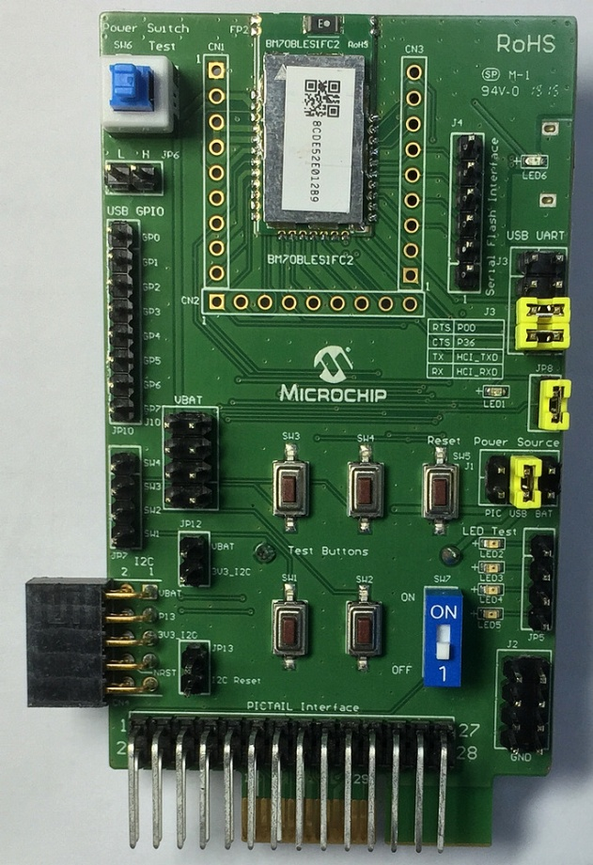

Figure 2.1 BLEDK3 EVB outlooks

## Environment Setup

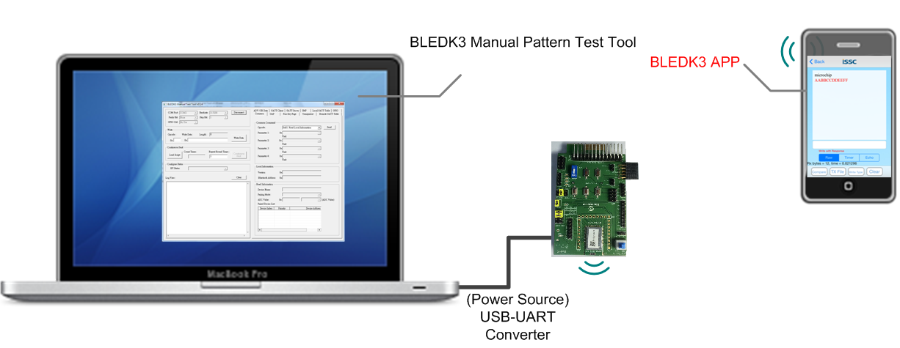

Figure 2.2 BLEDK3 environment setup

# Tool Overview



Figure 3.1 Tool view

There are four groups of panels labeled by numbers from to in this tool:

1. Settings: The configuration of **COM Port**, **Baud rate, Parity Bit, Stop Bit** and **GPIO Ctrl. GPIO Ctrl** is used to do MCU emulation for specific GPIOs control by MCP2200.

2. Write and Continuous Send: This panel is used for developing only.

3. Log View: It displays all traffic between tool and BLEDK3. Commands will show in red texts and events will come out in blue ones.

4. Function Pages: They are used to do different function controls for BLEDK3. All commands supported by BLEDK3 are divided into several categories: [Common]、[GAP]、[Passkey Page]、[Transparent]、 [ADV/SR Data]、[SMP]、[DIO] 、[GATT Client]、[GATT Server]、[Remote GATT Table] and [Local GATT Table] are described in next chapter.

# BLEDK3 Commands

## Common Page

The Common Page includes commands for retrieving configuration or information of BLEDK3.

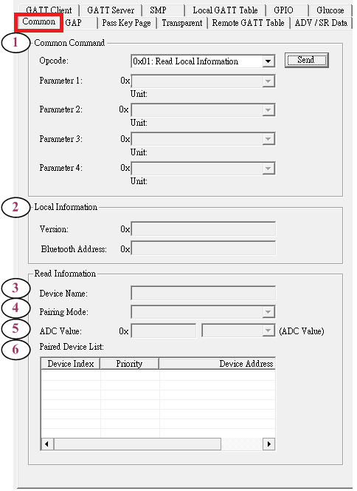

Figure 4.1 Common page view

1. The command set controller.

2. The response of the command (**0x01: Read Local Information**).

3. The response of the command (**0x07: Read Device Name**)

4. The response of the command (**0x0A: Read Pairing Mode Setting**)

5. The response of the command (**0x04: Read ADC Value**)

6. The response of the command (**0x0C: Read All Paired Device Information**)

## GAP Page

The GAP Page includes commands for creating or releasing the Link and retrieve some connection information.

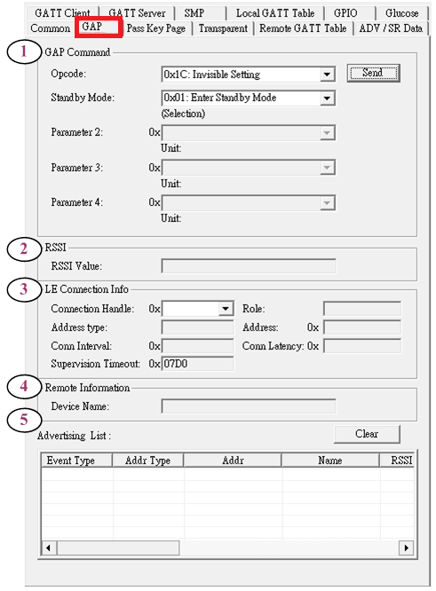

Figure 4.2 GAP page view

1. The command set controller.

2. The response of the command (**0x10: Read RSSI Value**).

3. The LE connection information will be displayed here when the LE connection is established.

4. The response of the command (**0x1F: Read Remote Device Name**).

5. The response of the command (**0x16: Set Scan Enable**).

## Passkey Page

The Passkey Page includes commands for sending Passkey after receiving the pairing request event.

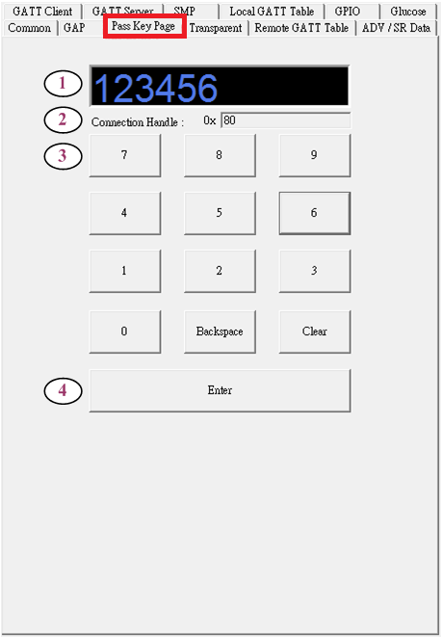

Figure 4.3 Passkey page view

1. This view will display the Passkey that user entered.

2. When the connection established, the Connection Handle will be filled automatically.

3. These buttons are used to send the command (**0x40: Passkey Entry Response**).

4. The Enter button is used to send passkey entry completed.

## Transparent Page

The Transparent Page includes commands and settings for transmitting data (from BM70 to remote device), a display console for raw data between BM70 and remote device and some related parameter and status display.



Figure 4.4 Transparent page view

1. This is used to send a segment of data.

2. When a connection is established, the Connection Handle will be filled automatically.

3. The repeated round times of data file transmission. (Keep repeating if this parameter set to 0).

4. The delay time between data blocks.

5. The size of an UART data block.

6. The current round of repeating transmission.

7. Amount of transmitted data.

8. Amount of received data.

9. The received data will be sent back while it is enabled.

10. Enable/disable the Compare function. The comparison will be triggered without incoming data for more than 3 seconds.

11. The result of comparison.

12. The elapsed time of the data receiving

13. Load a text file for transmission or received data comparison

14. Start to transmit the file

15. Save received data as a file

16. Clear the received data in the temporary file.

17. The raw data console included transmitted (displayed as red text) and received (displayed as blue text) data.

18. Clear the raw data in the console

## ADV / SR Data Page

The ADV / SR Data Page is used for updating the advertising and scan response data.

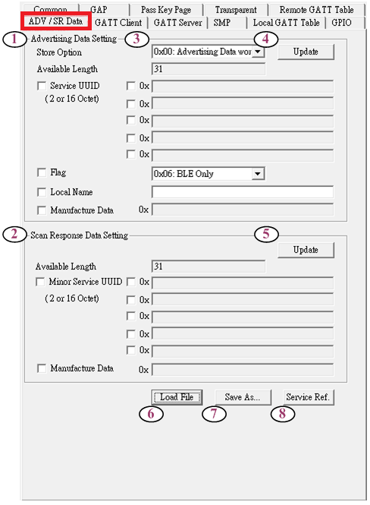

Figure 4.5 ADV/SR data page view

1. The advertising data editor.

2. The scan response data editor.

3. The store option of advertising data, save in EEPROM or not

4. To update the advertising data by sending command (**0x11: Write ADV Data**).

To update the scan response data by sending command (**0x12: Write Scan Response Data**).

To load the ADV / SR data file.

7. To save the ADV / SR data as a file.

8. To visit the services reference on the Bluetooth SIG official website.

## SMP Page

The SMP Page is used to initiate pairing procedure.

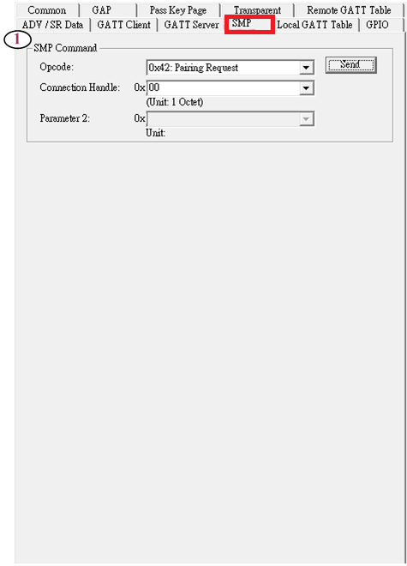

Figure 4.6 SMP page view

1. The command set controller.

## DIO Page

The DIO Page includes commands for control Configurable DIOs and PWM of **BLEDK3**.



Figure 4.7 DIO page view

1. The command set of DIO control.

2. The command set of PWM control.

## GATT Client Page

The GATT Client Page includes GATT client group commands for GATT client procedure.

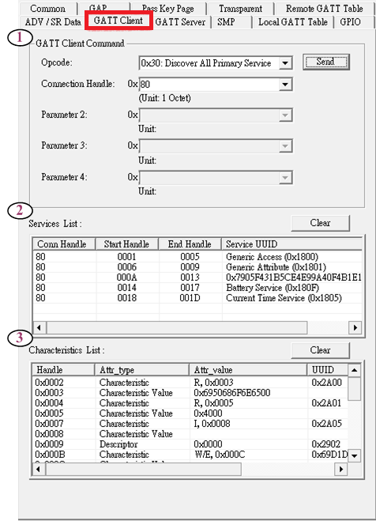

Figure 4.8 GATT client page view

1. The command set controller.

2. The response of the command (**0x30: Discover All Primary Services**).

3. The response of the command (**0x31: Discover Specific Primary Service Characteristics and Descriptor**)(**0x32: Read Characteristic Value**).

## GATT Server Page

The GATT Server Page includes GATT Server group commands for GATT server procedure.

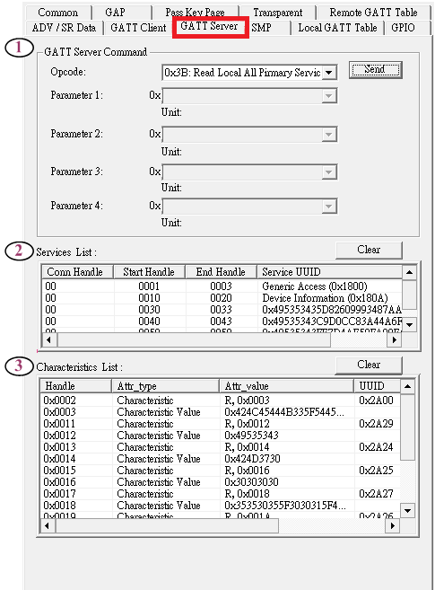

Figure 4.9 GATT server page view

1. The command set controller.

2. The response of the command (**0x3B: Read Local All Primary Services**).

3. The response of the command (**0x3C: Read Local Specific Primary Service**)(**0x3A: Read Characteristic Value**).

## Remote GATT Table Page

The Remote GATT Table Page is used for asking client’s service from server.

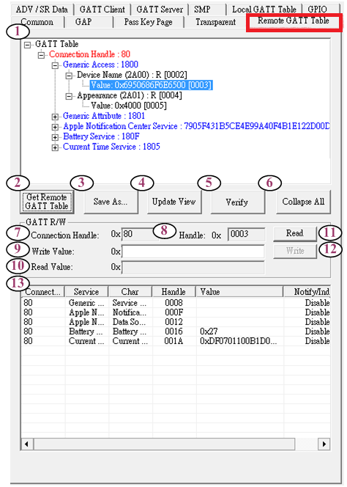

Figure 4.10 Remote GATT table page view

1. Show supported service of client

2. Start to get the GATT table.

3. Save the GATT table.

4. To update the GATT table.

5. To verify the GATT table.

6. To collapse or expand the GATT table.

7. When the GATT table is clicked, the Connection Handle will be filled automatically.

8. When the GATT table is clicked, the Characteristic Handle will be filled automatically

9. Write a characteristic value

10. Show characteristic value

11. Read Characteristic Value from server.

12. Write Characteristic Value to server.

13. Show support service of client

## Local GATT Table Page

The Local GATT Table Page is used for asking server’s service.

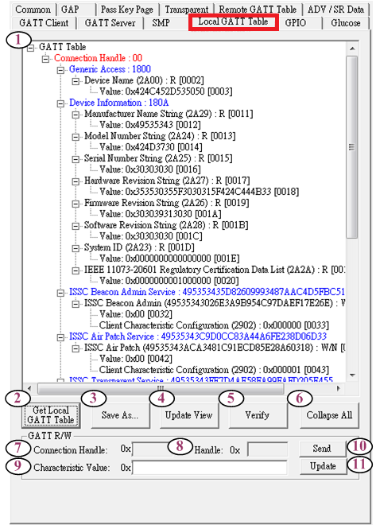

Figure 4.11 Local GATT table page view

1. Show support service of server

2. Start to get the Local GATT table.

3. Save the Local GATT table.

4. Update the Local GATT table.

5. Verify the Local GATT table.

6. Collapse or expand the Local GATT table.

7. When the Local GATT table is clicked, the Connection Handle will be filled automatically.

8. When the Local GATT table is clicked, the Characteristic Handle will be filled automatically

9. Write a characteristic value

10. Send characteristic value to GATT client

11. Update existing characteristic value of BLEDK3.

# Examples of Operation

## Connection

### Slave Role

As a slave role, BLEDK3 must enter Standby Mode to be discoverable before a connection is established.

1. Select [**GAP**] Page.
2. Choose the command (**0x1C: Invisible Setting**).
3. Set the Enter Standby Mode to be discoverable. (**0x01 or 0x02**).
4. Press the [**Send**] button to let BLEDK3 advertise and enter Standby Mode.

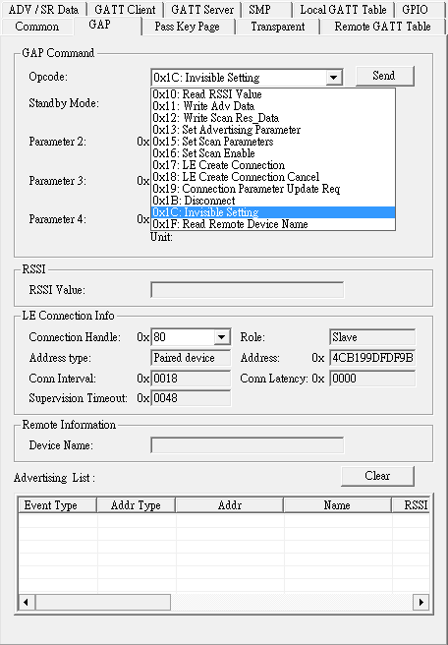

Figure 5.1.1 BLEDK3 enter standby mode

### Connection Complete

The following information shows you how to check BLE connection is established successfully.

1. The BT Status will change to **LE Connected Mode**
2. The connection parameters will be displayed in the [**GAP**] page.

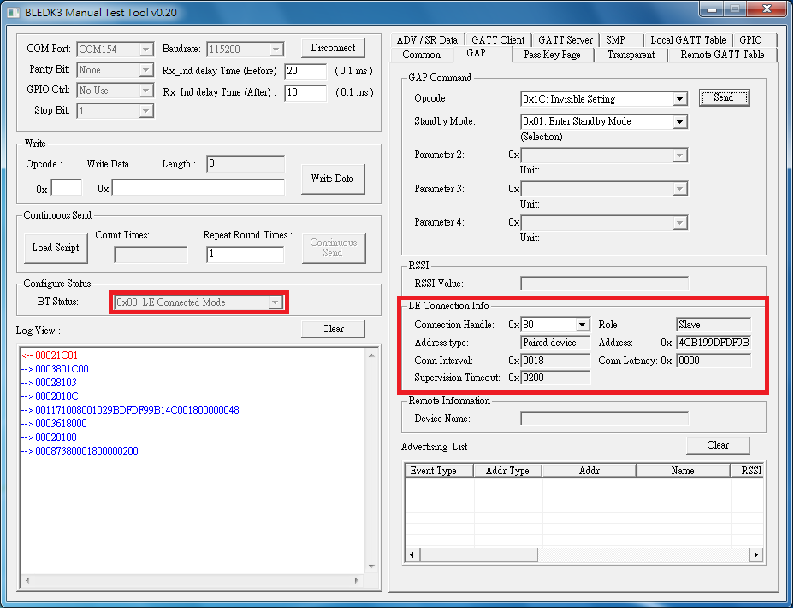

Figure 5.1.2 BLEDK3 in connected mode

## Disconnection

Disconnect a link as below steps:

1. Select the [**GAP**] Page.
2. Choose the command (**0x1B: Disconnect**).
3. Press the [**Send**] button to disconnect the connection.

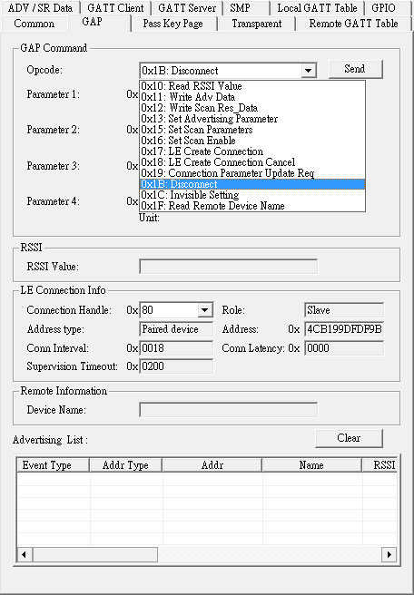

Figure 5.2.1 BLEDK3 disconnect the connection

There will pop up a message to show the disconnection reason after disconnection is completed.

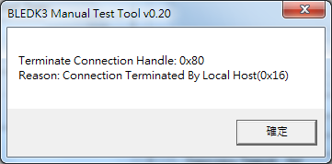

Figure 5.2.2 The disconnection message

## Transparent Service

### Transparent Operation

There are three ways to transmit data, send data、send a file and loop back mode.

* ***Send data:***

1. Input a segment of send data in the field.
2. Press [**Send**] button to start the transmission.

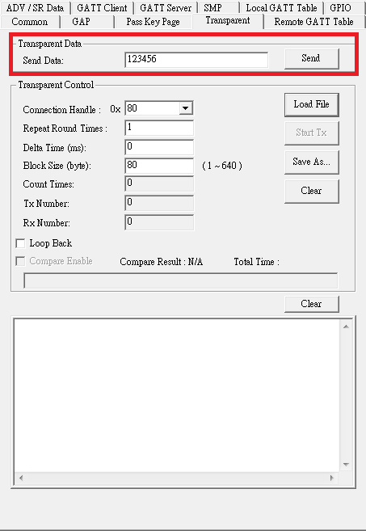

Figure 5.3.1 Send data

* ***Send a file:***

1. Press [**Load File**] button to load a text file.
2. Type the [**Repeat Round Times**], [**Delta Time**] and [**Block Size**].
3. Press [**Start TX**] button to start the transmission.

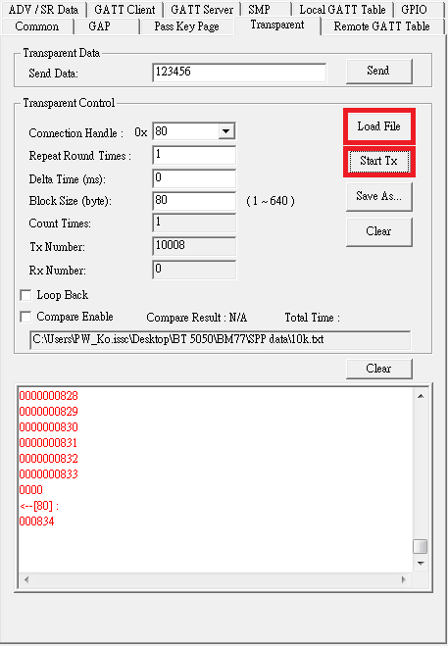

Figure 5.3.2 Send file

#### Loop back mode:

1. Check the Loop Back item.
2. The received data will be sent back.

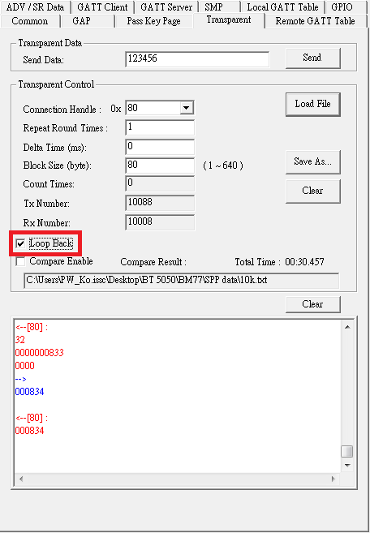

Figure 5.3.3 Send data with loopback mode

## ADV / SR Data Editor

1. Edit the advertising data and the scan response data.
2. Save / update ADV data.

### Edit the advertising data and the scan response data

The data setting is the same with the BLEDK3 UI tool, users can edit the **Service UUID**、**Local name**、**Flag** and **Manufacture Data.**

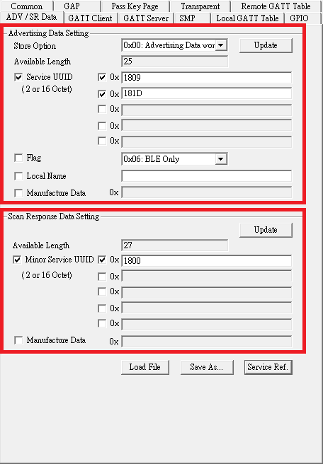

Figure 5.4.1 ADV/SR data editor

### Save as a file

Press [**Save As…**] to save the setting as a file. The file can be reused next time by **[Load File]**. This step is optional.

### Update ADV data

Press [**Update**] to update the ADV/SR data and start advertising automatically.

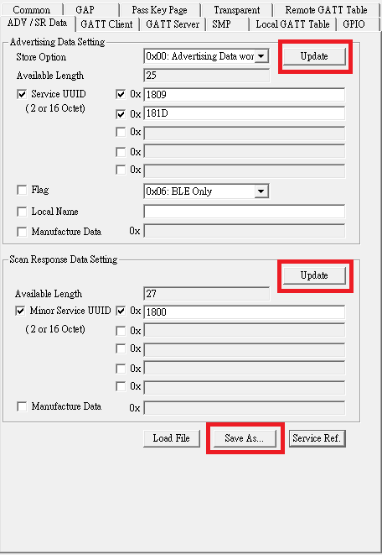

Figure 5.4.2 Update ADV/SR data

## Pairing

### Pairing Mode

There are 4 pairing mode**: JustWork**、**Passkey Entry**、**User Confirm and Passkey Confirm** ，but MCU just needs to take care of **Passkey Entry** and **User Confirm** only.

* ***Passkey Entry Request***

MCU needs to send the passkey after receiving the following message.

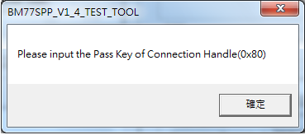

Figure 5.5.1 Passkey entry request message

* + ***Send Pass Key***

Press Enter button after entering the passkey.

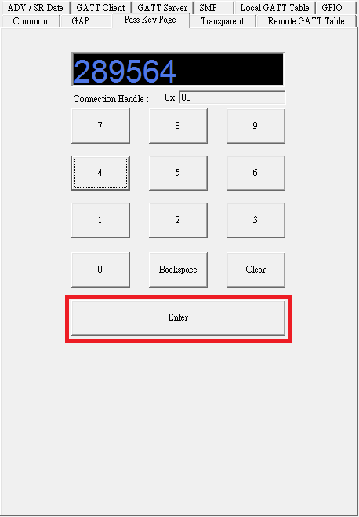

Figure 5.5.2 Send passkey

* ***Passkey Confirm Request***

MCU need to send passkey confirm after receiving the following message.

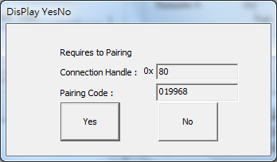

Figure 5.5.3 Passkey confirm request message

### Pairing Mode Setting

* ***Read Pairing Mode***

1. Select the **[Common]** Page.
2. Choose the command **(0x0A: Read Pairing Mode Setting)**.
3. Press the **[Send]** button to read the pairing mode.

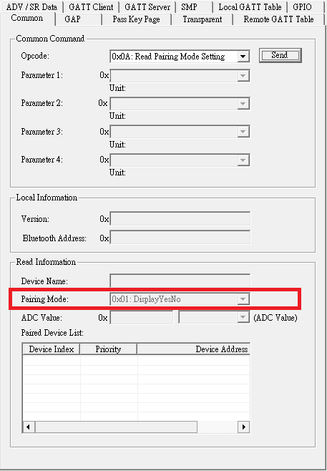

Figure 5.5.4 Read pairing mode

* ***Write Pairing***

1. Select the **[Common]** Page.
2. Choose the command **(0x0B: Write Pairing Mode Setting)**.
3. Select **[Pairing Mode]**
4. Press the **[Send]** button to disconnect the connection.

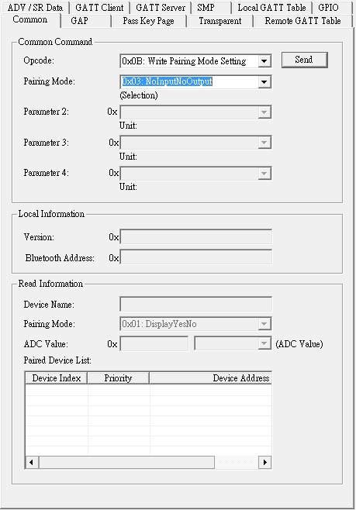

Figure 5.5.5 Write pairing mode

### Paired Device Information

* ***Read Pairing Data***

1. Select the **[Common]** Page.
2. Choose the command **(0x0C: Read All Paired Device Information)**.
3. Press the **[Send]** button to read all paired device information.

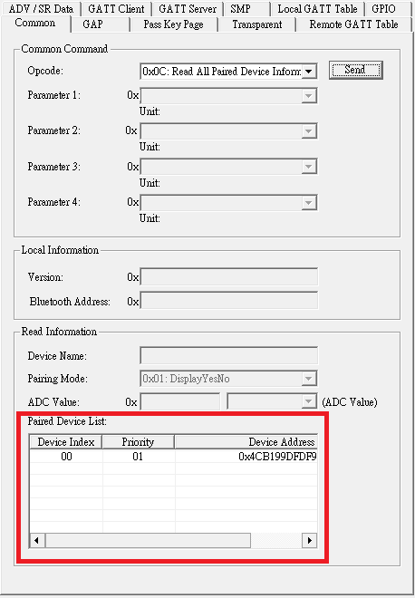

Figure 5.5.6 Read paired device information

* ***Erased Pairing Data***

There two command to erase the paired device information saved in BLEDK3 eFlash.

* + ***Delete Paired Device***

1. Select the **[Common]** Page.
2. Choose the command **(0x0D: Delete Paired Device)**.
3. Choose the index of the paired device you want to remove.
4. Press the **[Send]** button to delete the paired device by index.

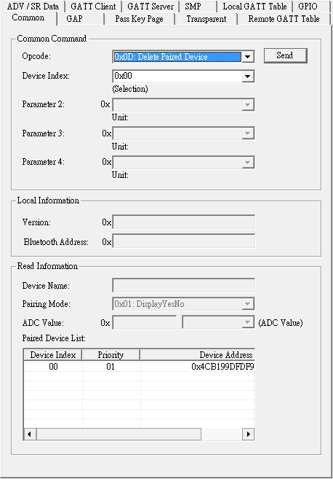

Figure 5.5.7 Delete paired device

* + ***Delete all Paired Devices***

1. Select the **[Common]** Page.
2. Choose the command **(0x09: Erase All Paired Device Information)**.
3. Press the **[Send]** button to erase all paired devices.

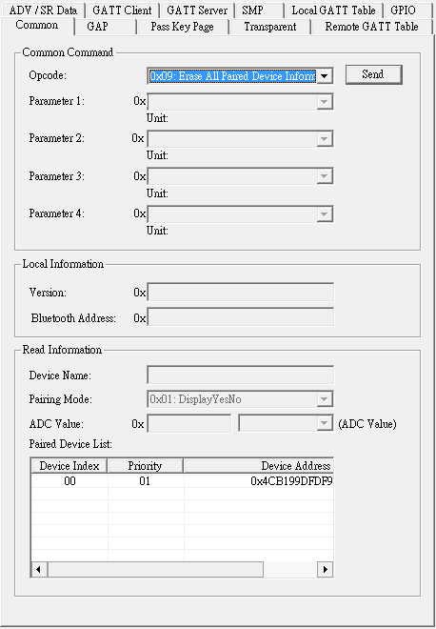

Figure 5.5.8 Delete all paired device

### Pairing Complete

When the pairing process is finished, MCU will receive a paining complete event from BLEDK3.

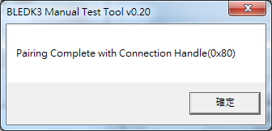

Figure 5.5.9 Pairing complete message

## Get Remote GATT Table

When the connection is established, the client can ask the service from the server.

1. Select the [**Remote GATT Table**] Page.
2. Press the [**Get Remote GATT Table**] button.

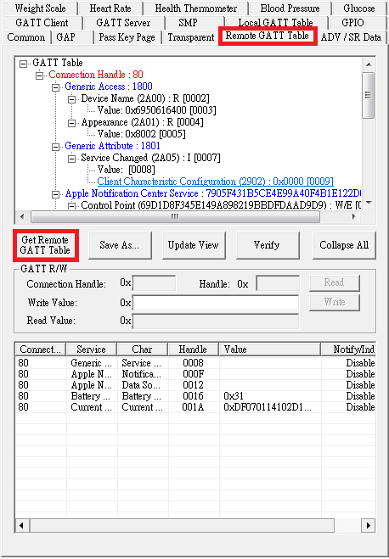

Figure 5.6.1 Get remote GATT table

## Get Local GATT Table and Specific service

The server can ask the service from local, and if server support [**Weight Scale**]、[**Heart Rate**]、[**Health Thermometer**]、[**Blood Pressure**] or [**Glucose**], after get Local GATT Table the Manual Pattern Test Tool will show specific service page.

1. Select the [**Local GATT Table**] Page.
2. Press the [**Get Local GATT Table**] button.

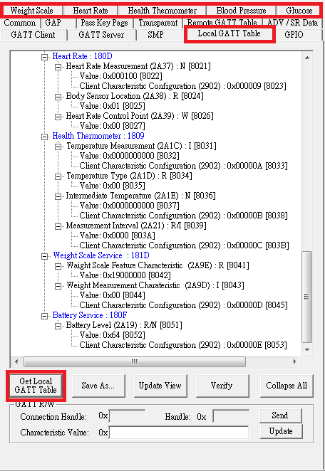

Figure 5.7.1 Get local GATT table

### Weight Scale Service

The Weight Scale Service exposes weight and related data from a weight scale (Server) intended for consumer healthcare as well as sports/fitness applications.



Figure 5.7.2 Weight scale service view

1. Demo Weight Scale Service.

2. Indicate Battery Level Characteristics

3. Read Battery Level Characteristics.

4. Read Weight Scale Feature Characteristics.

5. Indicate Weight Measurement Characteristics.

### Heart Rate Service

The HEART RATE Service exposes heart rate and other data related to a heart rate sensor intended for fitness applications.

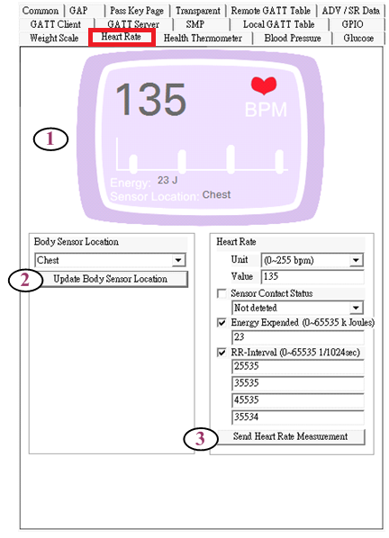

Figure 5.7.3 Heart rate service view

1. Demo Heart Rate Service.

2. Read Body Sensor Location Characteristics.

3. Indicate Heart Rate Measurement Characteristics.

### Health Thermometer Service

The Health Thermometer service exposes temperature and other data from a thermometer intended for healthcare and fitness applications.



Figure 5.7.4 Health thermometer service view

1. Demo Health Thermometer Service.

2. Read Temperature Type Characteristics.

3. Read Measurement Interval Characteristics.

4. Indicate Measurement Interval Characteristics.

5. Indicate Intermediate Temperature Characteristics.

6. Indicate Temperature Measurement Characteristics.

### Blood Pressure Service

The Blood Pressure Service exposes blood pressure and other data related to a blood pressure monitor.



Figure 5.7.5 Blood pressure service view

1. Demo Blood Pressure Service.

2. Read Blood Pressure Feature Characteristics.

3. Choose indicate Blood Pressure Measurement Characteristics or Intermediate Cuff Pressure Characteristics.

### Glucose Service

The Glucose Service exposes glucose and other data related to a glucose sensor for consumer and professional healthcare applications.



Figure 5.7.6 Glucose service view

1. Demo Glucose Service.

2. Glucose Measurement Characteristics.

3. Glucose Feature Characteristics.

4. Glucose Measurement Context Characteristics,

5. Record Access Control Point Characteristics.

* ***Glucose Measurement Characteristics***



Figure 5.7.7 Glucose measurement characteristics

* ***Glucose Feature Characteristics***

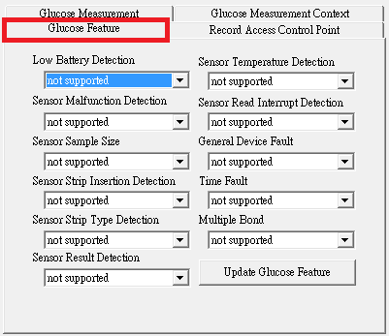

Figure 5.7.8 Glucose feature characteristics

* ***Glucose Measurement Context Characteristics***

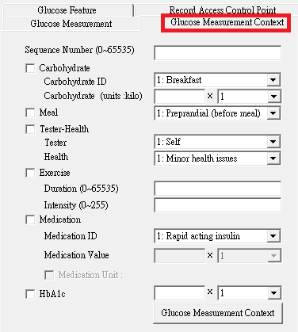

Figure 5.7.9 Glucose Measurement context characteristics

* ***Record Access Control Point Characteristics***



Figure 5.7.10 Record access control point chatacteristics

1. Display received Record Access Control Point command.

2. Indicate the Record Access Control Point with stored records.

3. Indicate the Record Access Control Point with number of stored records.

4. Indicate the Record Access Control Point with a Response Code Op Code and Response Code Value.

# Revision History

|  |  |  |
| --- | --- | --- |
| Version | Date | History |
| D026R01 | 2015/03/31 | First Edition of BLEDK3 Manual Pattern Tool User Guide |